**DML COMMANDS**

create table emp_expt5_csea_60(emp_id int primary key,emp_name varchar(20),dept varchar(20),salary int);  
  
desc emp_expt5_csea_60;  
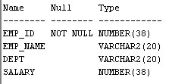  
  
insert into emp_expt5_csea_60 values(1,'David Smith','HR',5000);

insert into emp_expt5_csea_60 values(2,'Obama','Marketing',6000);

insert into emp_expt5_csea_60 values(3,'Charles Brown','production',3000);

insert into emp_expt5_csea_60 values(4,'Anthony Martial','sales',9000);  
  
select * from emp_expt5_csea_60;  
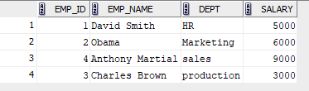

select * from emp_expt5_csea_60 where salary>7000;  
  
  
update emp_expt5_csea_60 set salary=8200 where emp_name='David Smith';   
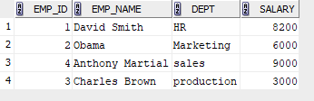  
  
insert into emp_expt5_csea_60 values(6,'Daniel Harris','Production',6700);  
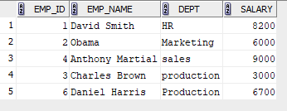  
  
delete from emp_expt5_csea_60 where emp_id=3;  
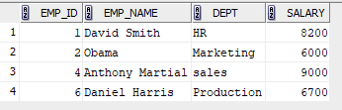  
  
  
select * from emp_expt5_csea_60 where emp_name not like 'D%' and emp_name not like 'O%';  
  
  
  
  
select dept,sum(salary) from emp_expt5_csea_60 group by dept;  
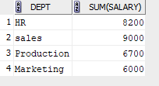  
  
update emp_expt5_csea_60 set salary=salary+salary*0.05 where dept='Production';  
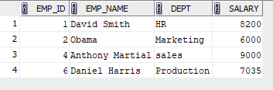  
delete from emp_expt5_csea_60 where salary<7000;  
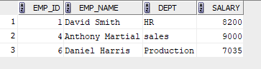

select emp_name,salary from emp_expt5_csea_60 where salary=(select min(salary) from emp_expt5_csea_60);  


update emp_expt5_csea_60 set salary=8200 where dept='Marketing';  
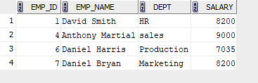  
select emp_name from emp_expt5_csea_60 where emp_name like 'A%';  
  
  
select emp_name from emp_expt5_csea_60 where emp_name like '%it%';  
  
  
select upper(dept) from emp_expt5_csea_60;  
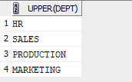  
  
select * from emp_expt5_csea_60 where dept like'M_r%ket%';  
  
  
  
  
select distinct upper(reverse(dept)) from emp_expt5_csea_60;  
